Minutes
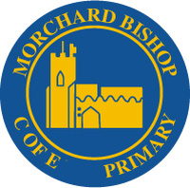

Morchard Bishop C of E Primary School
Church Street, Morchard Bishop, Crediton, Devon. EX17 6PJ Tel: 01363 877328
Email: adminmorchardbishop@thelink.academy

FOMBS Committee Meeting Minutes

Wednesday 2nd July 7.30pm

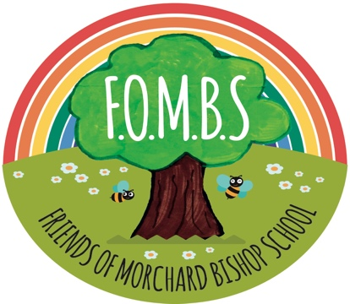

Officers | Gemma Yendell – Chair  Shelli Critchley – Vice Chair  Andrea Routledge - Secretary  Sadie Bullock – Treasurer | Jessica Morgan  Tash Yendell  Catherine Bradford  Hayley Pike  Fran Eden  Sophie Denham  Magda Drake-Browning

Apologies | Laura Scoins  Leanne Burnison  Shelli Critchley  Nikki Perry  Mrs Bancroft
Previous Minutes  February 25 | Minutes signed off | GY
Treasurers Report | Treasurers report:  Ice cream Purchases - £35.47  Sales - £135.30 (profit £99.83)  Balance - £14,605.83 (£7342.85 - laser, £1,550 - garden project) | SB
Garden Project/Path Update | Updated quote from RTC:  Wet pour - 1.2m - £21,181  1.5m - £25,723  Groundworks - 1.2m - £9,000 & 1.5m £10,000  Photo - In this picture the wet pour is the orange one, to have a colour it was another ~£4k so we opted for black.  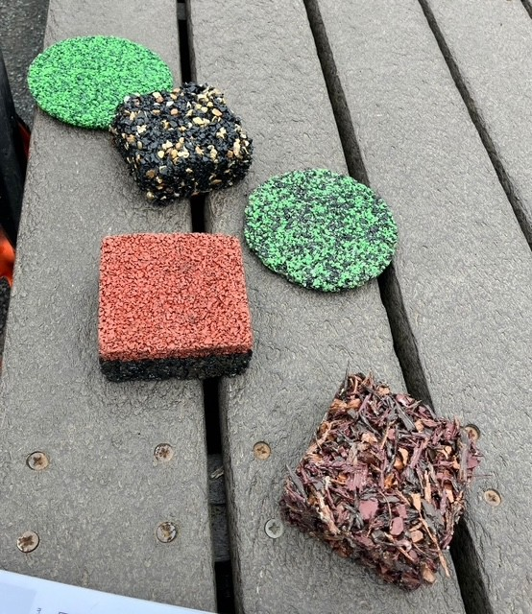 | SB  LB
Colour  run Update | The legalities of the colour run: Mrs B is happy for it to be run as a school event and not a FOMBS event.  Sub meetings will need a committee member to be present/involved.  Raised MDB  Seconded TY  Posters to be redone without FOMBS logo  Tickets on sale in the shop, and in school from next week.  Tickets will be sold from the entrance to school.  Path Information documentation  Information on the path project will be displayed for potential donation / sales  Traybake cakes/wrapped need to be made/donated.  Only School staff to be in the kitchen  Ideas for stalls:  Sweets  Soft drinks  Splat the rat  Tin can alley  Tattoos  Lucky dip box  Bubbles/smoke machine/music  Ticket price £5 for runners  Run will be marked out with 4 paint throwing points  Water sprinkler points, hose sprinklers needed on the day  Permanent markers for leavers to write on their t shirts  Selfie photo frame  Recommended 500gm per runner £2.75 per tub  Paint is non allergenic ect  Suggestion of sponsorship for colours  Jar Tombola | FE  SB  AR  MDB
New  Starter Packs | Poem  Making bundles  Tea, Coffee, Biscuit, Poem, Advert for FOMBS  x10 | TY  CB
Leavers Gifts | Completed x12 x1 for Miss Symns | TY
School Play Refreshments | Check with Mrs B for Pimms
Tesco partnership  Easy Fundraising | Apply from school Mrs B TBC  Quarterly deposits received  Readvertise again | Jess  TY
Ice cream Fridays | Fri 11th July TBC | GY
Vintage Fair | 2nd August u  Unfortunately, we can’t support the event this year by running games activities due to holidays.
AOB  School Pantomine  Parents Disco Sept  Dinner Dance Spring possibly March | TBC  TBC poss 19th Sept /3rd Oct  TBC
Date / time for the next meeting | Wednesday 24th September FOMBS AGM followed by FOMBS meeting
Close

